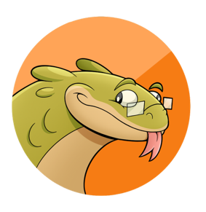
John (Jack) Torres
(626) 241-8892
luhlizurd@gmail.com

Skills
• Animation pipeline understanding • Autodesk Maya
• Toon Boom Harmony/Storyboard Pro • Adobe Creative Suites
• Communication • Storytelling
• Project management • Nomad Sculpt
• Z Brush Software

Work History
Intern, IndieToy, 2025–Present
• Created concept art for multiple Indie Game studios and bands
• Created 3D models for future toy releases
• Created standalone toy for personal brand
• Worked within the toy production pipeline with team of multiple artists
• Created tech packs for plush toy releases

Director/Storyboard Artist/Character Designer/Writer, Moth-Mart, 2022–2024
Art Center College of Design
• Pitched, wrote, directed, and boarded my student film “Moth-Mart”
• Created animation pipeline
• Coordinated and recruited animators, layout artists, compositors, voice actors and musicians
• Created marketing to recruit experienced personnel to work on the film
• Utilized Storyboard Pro, Toon Boom Harmony, Adobe After Effects and Photoshop to create film

Animator, Postmortem, 2023–2024
Art Center College of Design
• Character animator and designer
• Utilized Toon Boom Harmony and Photoshop for the student film “Postmortem”

Storyboard Artist/Animator/Colorist, Flight of Atlas, 2024-2026
Art Center College of Design
• Storyboarded multiple sequences, including character acting and action sequences
• Animated multiple sequences, including character acting and animal sequences
• Colored multiple shots and exported frames
• Utilized Storyboard Pro and Toon Boom Harmony

Animator, No Vacancy, 2024
Art Center College of Design
• Character animator, animation exporter
• Utilized Unreal Engine and Maya for the student film “No Vacancy”

Interpretive Volunteer, June 2019–July 2022
La Brea Tar Pits
• Greeted and interacted with visitors on a variety of levels, including answering questions about the museum’s vast collection
• Acted as an informal educator by interpreting the Museum’s exhibits for its diverse visitors

Education
B.S. in Entertainment Design, Animation/Art Center College of Design
Pasadena, CA/GPA 3.9/Expected graduation: May 2026

